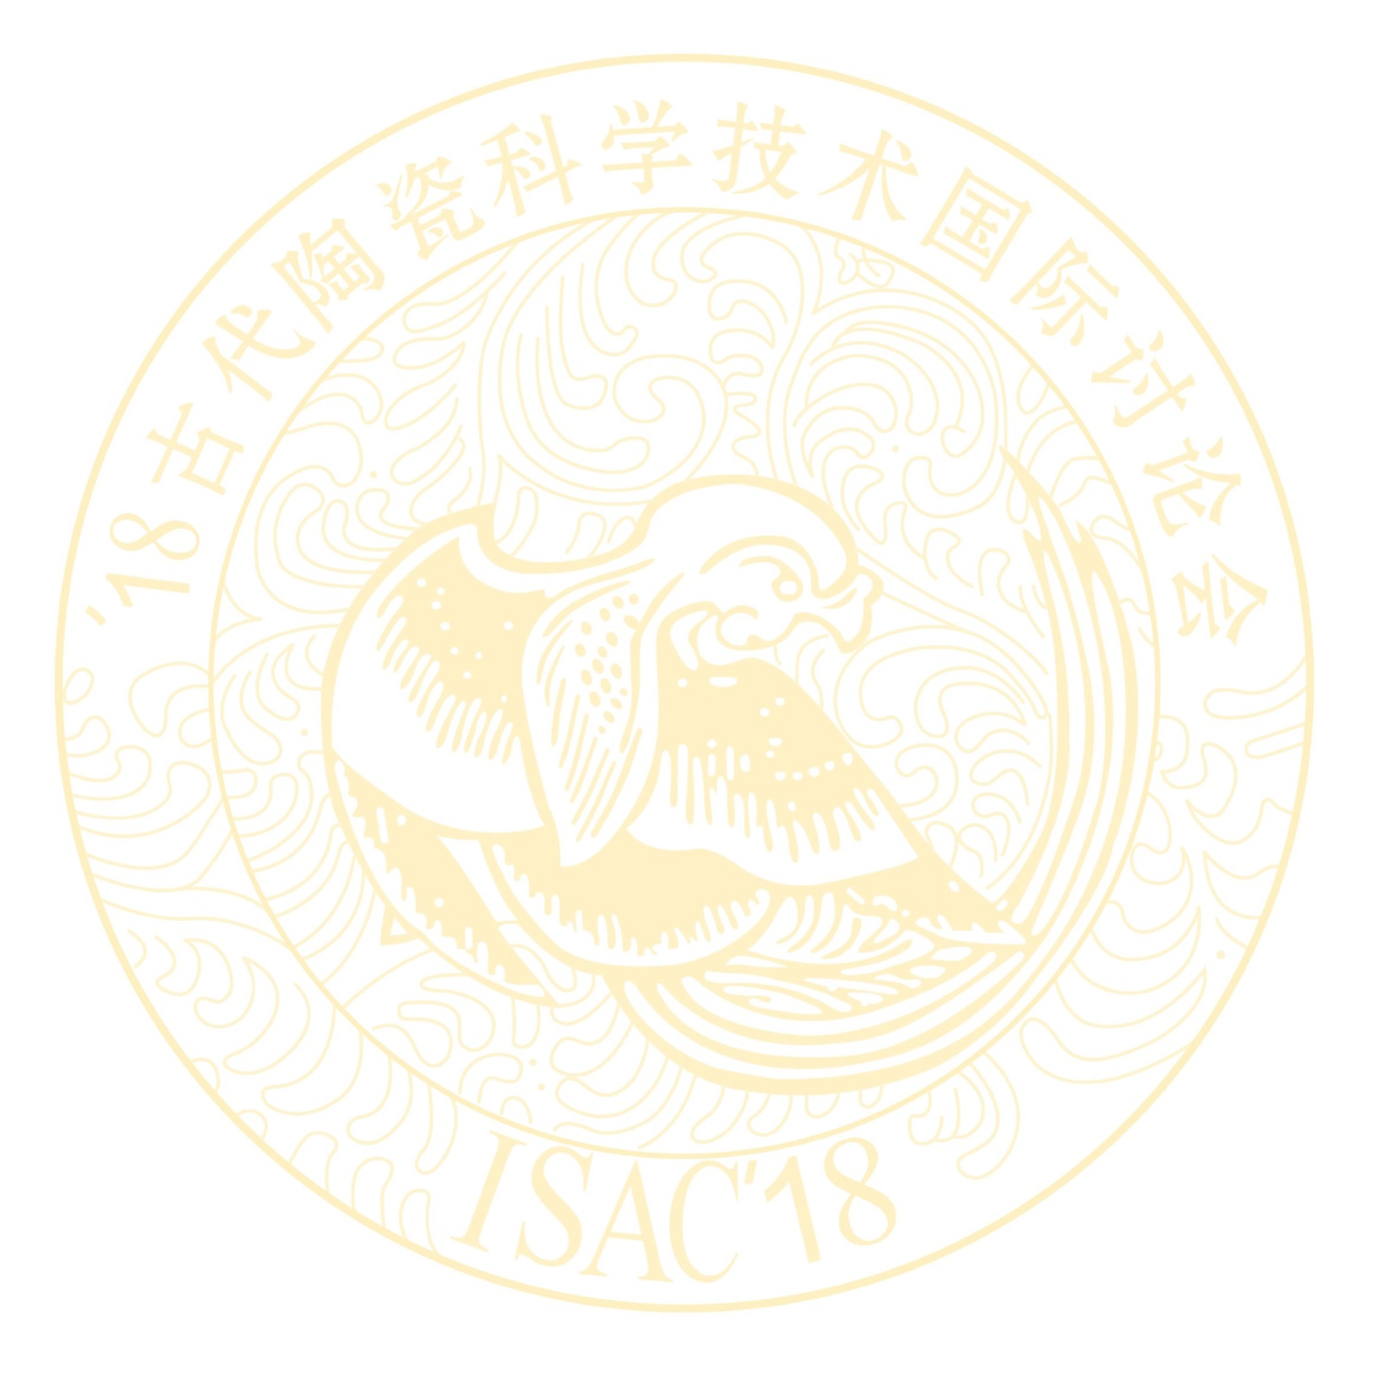
Notice No. 2 of

2018 INTERNATIONAL SYMPOSIUM ON ANCIENT CERAMICS
-Its Scientific and Technological Insights
(ISAC 2018)

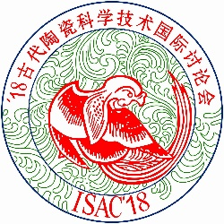

November 6 ~ 9, 2018
Hope Hotel, Shanghai, China

Sponsored by:
Shanghai Institute of Ceramics, Chinese Academy of Sciences
Organized by:
Shanghai Research Society of Science and Technology of Ancient Ceramics (SRSSTAC)
Introduction to the Symposium
The 2018 International Symposium on Ancient Ceramics (ISAC-2018) will take place in Shanghai, China on November 6-9, 2018. The International Symposium on Ancient Ceramics (ISAC) has been proved to be a high-level academic symposium and an important platform for academic exchange amongst ancient ceramic experts at home and abroad. Since the first symposium in 1982, ISAC has won high praises from academic researchers and experts from all over the world. Following the symposium, there will be an optional 4-day field trip to Zhejiang, China. Please find more details on Page 2.

Symposium Topics:
- Science and technology of ancient ceramics
- Archaeology of ceramics
- Trading of ancient ceramics
- Techniques and artistry of ancient ceramics
- Analytical methods
- Kiln and imitation
- Preservation and Restoration

Language used in the Symposium:
- English (15minutes for speech and 5 minutes for Q&A).

Schedule:
Please check in at HOPE Hotel on November 6, 2018. The Symposium will begin on November 7 and conclude on November 9. The post-symposium field trip will run from November 10 to November 13. Participants of the field trip will check out of hotel before noon of November14.

Symposium Registration Fee:
Including proceedings, meals, coffee break, stationery etc. Paying Registration fee for:
Participant:
Before July 31, 2018: ¥3000(RMB)/person;
After July 31, 2018: ¥3200 (RMB)/person,
Accompanying guest (excluding proceedings):
Before July 31, 2018: ¥2000(RMB)/person;
After July 31, 2018: ¥2200(RMB)/person,
Student:
Before July 31, 2018: ¥2000(RMB)/person;
After July 31, 2018: ¥2200(RMB)/person.
Hotel Accommodation:
All participants are kindly requested to cover their own accommodation cost at HOPE hotel. Please refer to the following room types and rates.

- HOPE Hotel:
Suite room：about ¥800(RMB)/room per day
Single room：about ¥600(RMB)/room per day
Double room：about ¥620(RMB)/room per day
Address: No. 500, Zhaojiabang Road, Xuhui District, Shanghai.

- Tel: 0086-21-64716060
http://www.hope-hotel.com
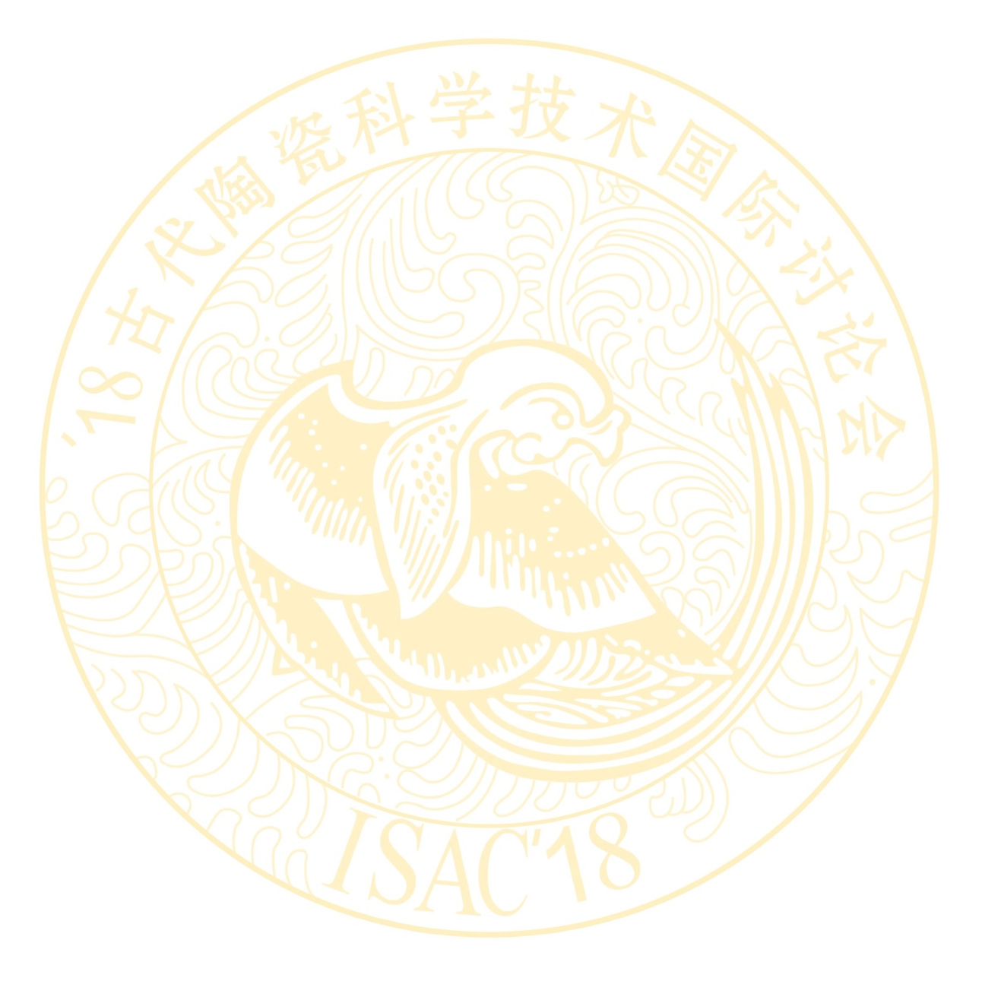
Post-symposium Field Trip : (November 10 - 13, 2018)

There will be an optional 4-day field trip to Zhejiang following the symposium. Attendance to the symposium is not required for the participation of the trip. The participants will visit a number of sites and museums within Zhejiang province, which hold the collections of the proto-porcelain, Yue kiln celadon, and the Southern Song dynasty imperial kiln celadon. The trip focuses on learning the celadon achievements in Zhejiang area and some latest archaeological discoveries. The itinerary is built around the following spots.

1. The Shanglinhu Yue kiln national archaeological site park covers the Housiao kiln site, the Hehuaxin kiln site, the Shanglinhu Yuekiln Museum, etc. The Housiao kiln site is renowned for its excavation of the secret color porcelain of the Tang and Five dynasties, which is deemed as one of “the top ten new archaeological discoveries in 2016".

2. At the Zhejiang Shangyu Jinshan early Yue kiln site, porcelain kilns in a complete sequence were found. These kilns belong to the period of the Eastern Han dynasty to the Western Jin dynasty. As tens of thousands of pieces of Yue kiln porcelain were unearthed, this discovery was among "the top ten new archaeological discoveries in 2014". A visit to the Shangyu museum will also be included in the trip.

3. The Hangzhou Southern Song dynasty imperial kiln museum accomodates the Southern Song dynasty imperial kiln-Jiaotanxia kiln site, the cultural relics display of southern song dynasty imperial kiln, etc. The kiln site consists of a workshop and the dragon kiln. The great amount of excavated porcelain speaks for the wide application of porcelain in the Southern Song Dynasty palace. As part of the trip, participants will also visit the Gushan section of Zhejiang province museum by the beautiful West Lake.

4. The proto-porcelain exhibition at the Zhejiang Deqing county museum is another must-see. The production of proto-porcelain in Deqing starts in the Shang dynasty, and develops over the Western Zhou dynasty, the Spring and Autumn period, and the Warring States period. Deqing County is the oldest and most productive birthland to the proto-porcelain in China.

Field Trip Registration Fee:

¥6500(RMB)/Participant (Or one participant and one guest ¥11500(RMB)).
The fee covers accommodation, meals, transportation, and other miscellaneous costs during the 4-day trip.

Method of Payment

Please remit the registration fee and/or the Field Trip fee to the following bank account and address, and indicate the purpose of payment (ISAC’18/trip, Your name, Comany). Personal check will not be accepted.

A/C No.: 1001223609014446346
Beneficiary Name:
Shanghai Research Society of Science and Technology of Ancient Ceramics
Swift CODE: ICBKCNBJSHI
Bank Name: Industrial and Commercial Bank of China Shanghai Municipal Branch Changning Sub-Branch
BANK ADDRESS: No.895 West Yan’an Road Shanghai China
Beneficiary Address: 1295 Dingxi Road, Shanghai 200050, P.R. China

Passport and Visa upon receiving your Registration Form and a copy of your Remittance Receipt, we will send out a letter of invitation for your visa application. Citizens of all other nations are required to obtain visas from the Chinese Embassy or Consulate General of the People’s Republic of China. Please inform us on the Embassy or Consulate General that you will obtain your visa from by filling in the Registration Form attached below, so that we can send a complete list of names to the proper diplomatic establishment.

Contact Person:
Ms. Xu Changsong, xuchangsong@student.sic.ac.cn
Mr. Lu Xiaoke, luxiaoke@mail.sic.ac.cn
Ms. Gu Zhonghua, guhua@mail.sic.ac.cn

Shanghai Institute of Ceramics,
Chinese Academy of Sciences,
1295 Dingxi Road, Shanghai 200050

Tel.: +86 21 52411107 or 52411108
Fax: +86 21 52411107

The sight of the Hotel：

Platinum Hanjue Hotel：
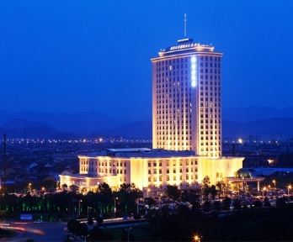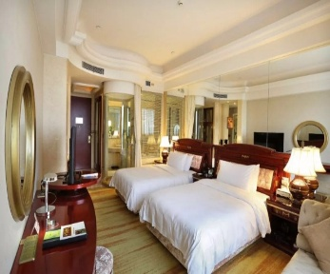
Shangyu Hotel：
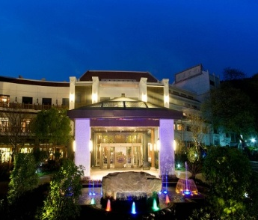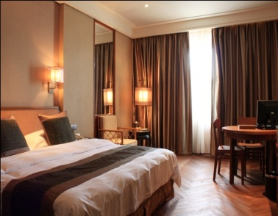
Chaowang Hotel：
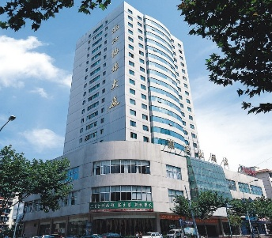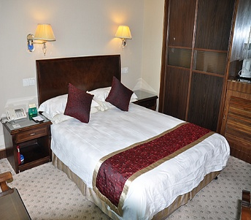
Indoor and outdoor scene of the Hotel

The weather of Zhejiang Province：Zhejiang Province has a subtropical monsoon climate. It is mild and comfortable in November, with a temperature between 10℃ and 19 ℃.
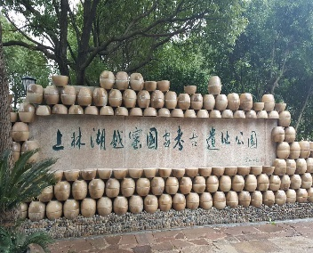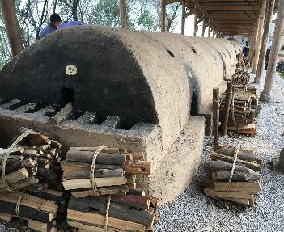
National archaeological site park of
Shanglin Lake Yue Kiln
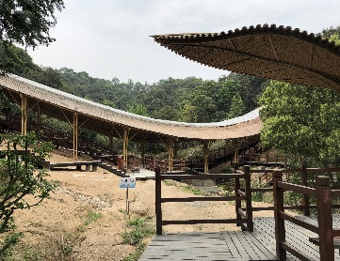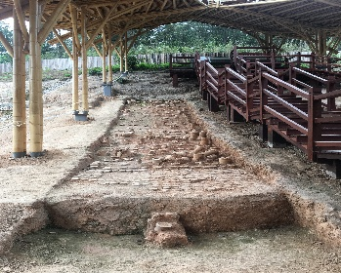
Jinshan Kiln Site
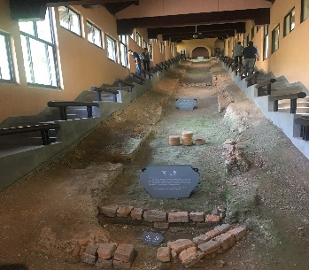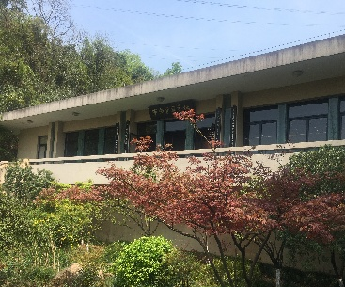
The Site of the Southern Song Dynasty Imperial Kiln

2018 INTERNATIONAL SYMPOSIUM ON ANCIENT CERAMICS
----Its Scientific and Technological Insights

ISAC ’18

November 6-9, 2018, Shanghai, China

REGISTRATION FORM
Please complete and return this form with a copy of your remittance receipt to Ms. Xu Changsong, Secretariat of ISAC’18, no later than July 31, 2018. Your information in this form is also required for visa application.

Full Name of Participant/ Accompanying Guest:
(Dr./Prof./Mr./Mrs./Miss) ,
(Surname) (First name)
Sex: Male/Female
Date of Birth: Nationality:

Present Occupation and Position:

Organization:

Mailing Address:

City: State:

Zip: Country:

Phone: Telex:

Fax: E-Mail:

Passport No.: Date and place of issue:

Application for Chinese visa to be made to Chinese Embassy/ Consulate General in

Fly to China by Flight No.

from (place) to

Estimated time and date of arrival in Shanghai:

Will leave China from for (place) on (date)

by Flight No.

Hotel Accommodation from Nov. 6-9, 2018:

Suite room about ¥（RMB）800/room per day ( )
Single room about ¥（RMB）600/room per day ( )
Double room about ¥（RMB）620/room per day ( )
Other (Arrange accommodation by myself) ( )

Notice: The participants who join the Zhejiang Field Trip will leave China from Shanghai on Nov.14, 2018. While the participants who won’t make the tour will leave China from Shanghai on Nov.10, 2018.

Payments: (Chinese Yuan)

- Registration Fee:
Participant Before Jul 31, 2018 ¥（RMB）3000 ( )
After Jul 31, 2018 ¥（RMB）3200 ( )

Accompanying guest Before Jul 31, 2018 ¥（RMB）2000 ( )
Accompanying guest After Jul 31, 2018 ¥（RMB）2200 ( )

Student Before Jul 31, 2018 ¥（RMB）2000 ( )
After Jul 31, 2018 ¥（RMB）2200 ( )

- Field Trip from Nov. 10, 2018 to Nov 13, 2018:

One Participant ¥（RMB） 6500 ( )
One Participant and one accompanying guest ¥（RMB） 11500 ( )

Total

Grand Total Remitted to Bank Name:
Industrial and Commercial Bank of China Shanghai Municipal Branch Changning Sub-Branch.
Bank Address: No.895 West Yan’an Road Shanghai China.
Swift Code: ICBKCNBJSHI , A/C No: 1001223609014446346.
Beneficiary Name: Shanghai Research Society of Science and Technology of Ancient Ceramics.
Beneficiary Address: 1295 Dingxi Road, Shanghai 200050, P.R. China.

Date: Signature:

